OT4 United Kingdom 1, 1 Samuel
Dr. Marvin J. Effa
Author: Samuel and others (1 Samuel 10:25, and 1 Chronicles 29:29).

Date of writing: 930 B.C. and later. 1 Samuel 27:6 indicates a divided monarchy. The Hebrew Bible “sub-divided each of them so as to form four Books of Kingdoms. The Latin Vulgate in the course of time dropped the term books of kingdoms (Libri Regnōrum) and shifting to the Hebrew division between Samuel and Kings, came out with the titles which the Western church has employed ever since. (But the Eastern Church still speaks of 1 and 2 Samuel as 1 and 2 Kingdoms and refers to 1 and 2 Kings as 3 and 4 Kingdoms.) Not until the Bomberg edition of 1517 did the Hebrew Bible make the partition of Samuel and Kings into two books.”
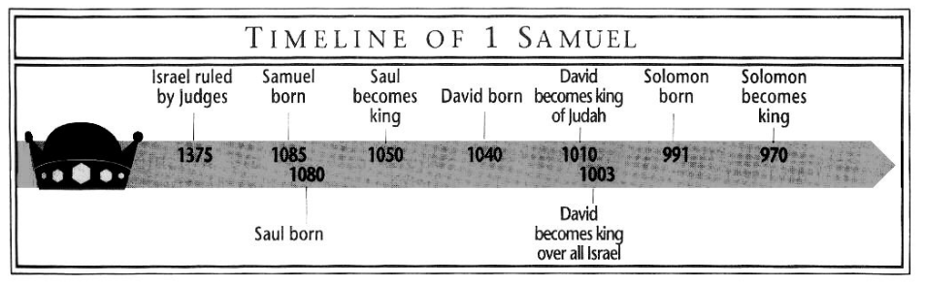
Purpose: First Samuel traces the decline of Saul in his disobedience (The Tale of Two Giants), and the rise of David in his obedience.

Idea: The rise and fall of Israel and her kings is tied to walking with the Lord.

Development:
1 Samuel covers the lives of four men: Eli, Samuel, Saul and David.
Eli and Samuel failed to pass on their commitments to their children.
Saul failed to walk with the Lord.
David, though anointed as the replacement king, refused to slay Saul, and God rewarded his humility.

1 Samuel:
- The career of Samuel and the deliverance from Philistia, 1:1–7:17.
- The rise of King Saul, 8:1–15:35.
- The decline of Saul and the rise of David, 16:1–31:13.

Key Passage Exegesis
- Transition from judges to prophets/kings, 1 Samuel 3:20, 4:18, 7:15.
- Not an ordinary box (ark), 1 Samuel 4-7.
- People’s demand for a king, 1 Samuel 8.
- A stubborn, self-centered king: Saul, 1 Samuel 9-15.
- A demonized king and David, his replacement, 1 Samuel 16.
- David and Goliath, 1 Samuel 17.
- David and Abigail, 1 Samuel 25.
- Saul and the witch of Endor, 1 Samuel 28.

The House of King Saul
Saul married Ahinoam. The sons were Jonathan, Abinadab, Malchishua and Ish-bosheth. Their daughters were named Merab and Michal. Saul also had a concubine named Rizpah, who bore him two sons, Armoni and Mephibosheth, 2 Samuel 21:8.
Saul offered Merab to David as a wife after his victory over Goliath, but David was not interested in the arrangement. Saul then gave his other daughter Michal in marriage to David, but when David became Saul's rival to the kingship, Saul gave Michal in marriage to Palti, son of Laish.
Saul and three of his sons (Jonathan, Abinadab and Malchishua) died at the Battle of Mount Gilboa. Ish-bosheth became king of Israel, reigned for two years and was killed by two of his own captains. Michal was returned as a wife to David, but was childless.
Armoni (Saul's son by his concubine, Rizpah) were given by David along with the five sons of Merab (Saul's daughter) to the Gibeonites, who killed them.
The only male descendant of Saul to survive was Mephibosheth, Jonathan's lame son. Mephibosheth had a young son, Micah, who had four sons and descendants named until the ninth generation.

OT4 United Kingdom 1: 2 Samuel

Author: Samuel and others (1 Samuel 10:25, and 1 Chronicles 29:29).

Date of writing: 930 B.C. and later.

Purpose: Second Samuel follows the establishment of David’s kingdom as he walked with the Lord, and the decline of his kingdom as he displeased the Lord.

Idea: The rise and fall of Israel and her kings is tied to walking with the Lord.
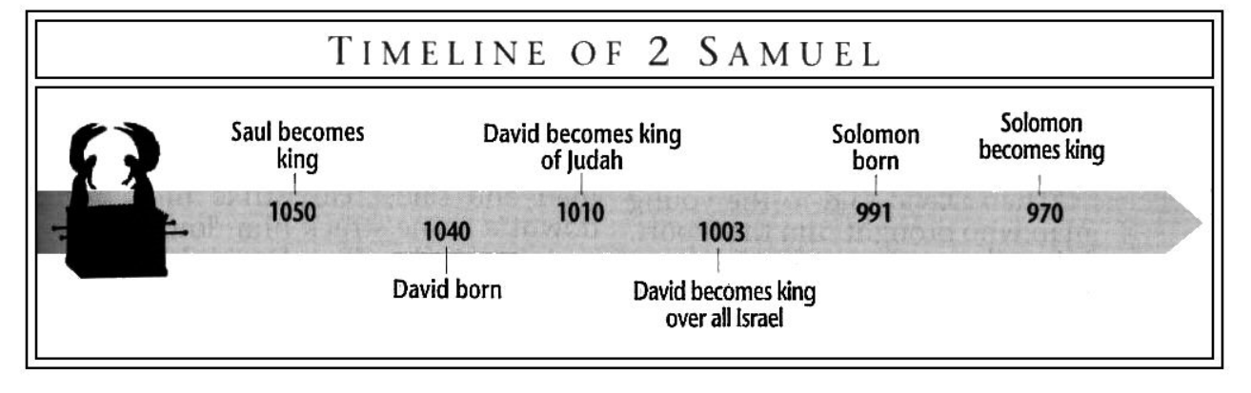
Development:
2 Samuel
- Civil war after Saul’s death and the consolidation of the kingdom, 2 Samuel 1-10.
- Adultery (11a), murder (11b), judgement (12), incest (13), rebellion (14-18), disorder (19-20), famine (21a), 2 Samuel 11-21.
- David’s memoires, 2 Samuel 21:15-24.

Key Passage Exegesis
- The problem of David’s generals, 2 Samuel 2-3.
- The Davidic Covenant, 2 Samuel 7:4-17.
- David’s sins, 2 Samuel 11.
- Trusting the Lord during self-caused adversity, 2 Samuel 16.
- David’s mighty men, 2 Samuel 23.
- David’s numbering of the people, 2 Samuel 24.

The House of King David
David was born in Bethlehem. His grandfather was Obed, whose mother was the Moabite Ruth and whose grandmother was the prostitute Rahab. David's father was Jesse. David had six older brothers and two sisters, Zeruiah and Abigail.
David had eight wives: Michal, the second daughter of King Saul; Ahinoam the Jezreelite; Abigail the Carmelite, previously wife of Nabal; Maachah, daughter of Talmai, king of Geshur; Haggith; Abital; Eglah; and Bathsheba. In Hebron, David had six sons: Amnon, by Ahinoam; Daniel, by Abigail; Absalom, by Maachah; Adonijah, by Haggith; Shephatiah, by Abital; and Ithream, by Eglah. By Bathsheba, his sons were Shammua, Shobab, Nathan and Solomon. David's sons born in Jerusalem by other wives included Ibhar, Elishua, Eliphelet, Nogah, Nepheg, Japhia, Elishama and Eliada. Jerimoth, who is not mentioned in any of the genealogies, is mentioned as another of his sons in 2 Chronicles 11:18. David also had at least one daughter, Tamar, by Maachah.
Commander Joab
Joab was the son of Zeruiah, a sister of King David, and had two brothers, Abishai and Asahel. Abner (Saul’s commander) killed Asahel, so Joab, against David's wishes, murdered Abner, 2 Samuel 2:13-32; 3:27. He led the army against Aram, Ammon, Moab and Edom. He also took part in David's murder of Uriah, 2 Samuel 11:14-25.
Joab defeated Absalom, of David's sons, and killed him against David’s commands, 2 Samuel 8:1-33. Joab confronted David about his misplaced grief, 2 Samuel 19:1-8. David replaced Joab with his nephew, Amasa, whom Joab killed, 2 Samuel 19:13, 2 Samuel 20:8-13. Joab sided with Adonijah, one of David’s sons, rather than Solomon and was killed by Solomon’s commander, Benaiah.

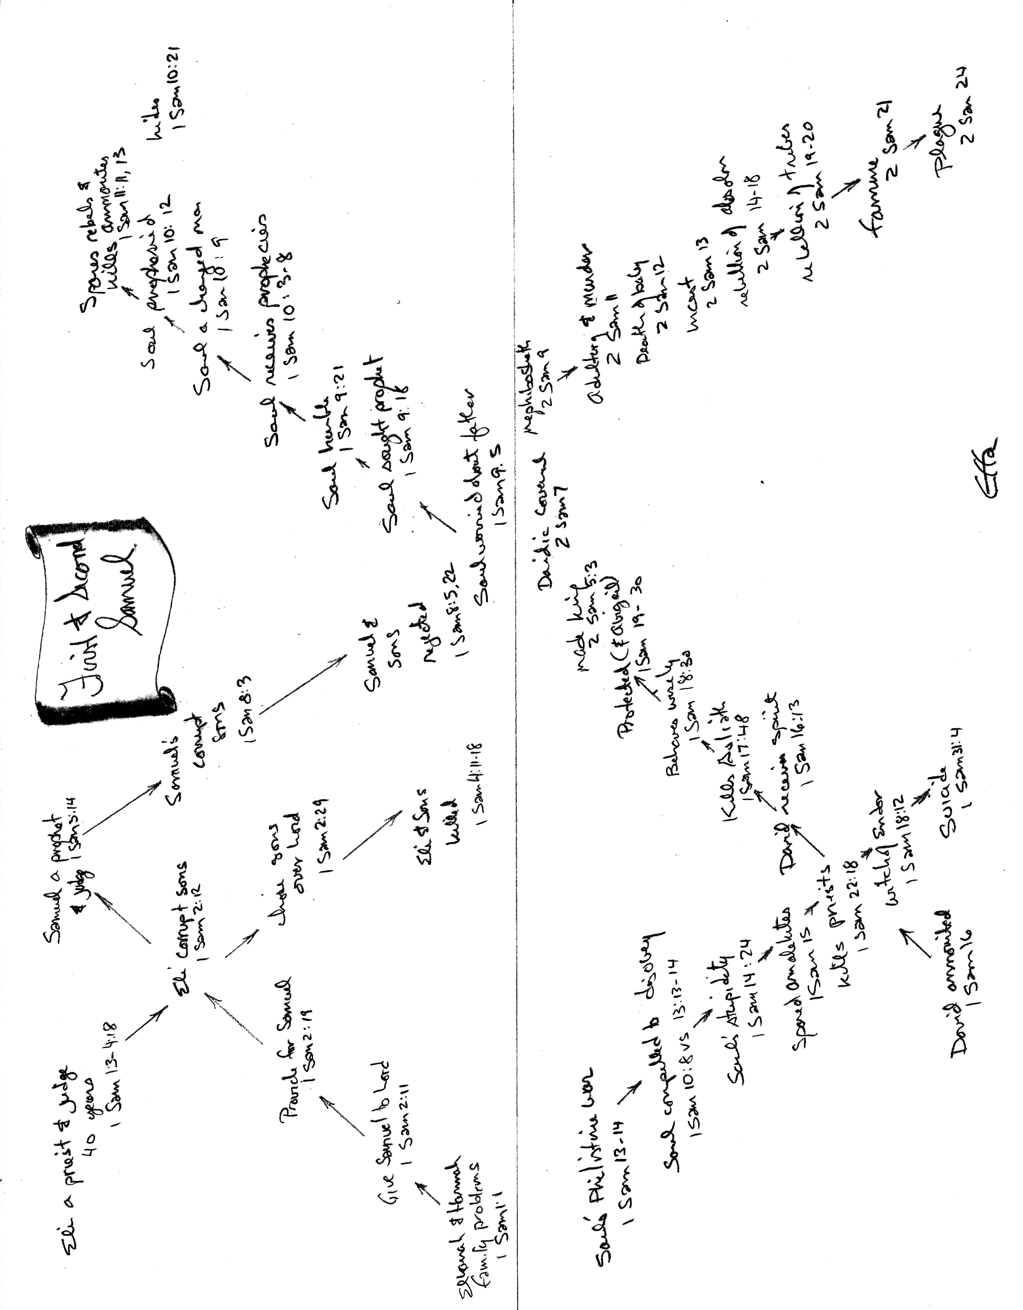

Archer, G., Jr. (1994). A survey of Old Testament introduction (3rd. ed., p. 311). Chicago: Moody Press.

